Fifth Grade Weekly Homework Sheet 3
Name__________________________ Date _____________Score _____________________________
CCSS | MONDAY | WEDNESDAY
Number and Operations Base Ten:  5.NBT
  48, 499.11 + 45,347.86
  Round to the GREATESTPLACE
  then add.
  $282,760.07 - $47,744.85
  Subtract, then round to the HUNDREDS place
Number and Operations Base Ten:  5.NBT | Write in standard form:  Forty-two thousand, twelve | A store donated 987 pencils to be given to classrooms. If there are 6 classrooms, how many pencils will each class get?
Operations and Algebraic Thinking  5.OA | Write an expression that means  4 less than 12, then multiply times 9. | Write a situation that fits the following expression:  (15 + 10) ÷ 5  (Write the problem on your other sheet.)
Number and Operations Fractions:  5.NF | Draw a number line that shows 0 to 1, then label the following fractions:  1/8, 1/4, 1/2, 7/8 | Add, then write the answer  in lowest terms.  2/8 + 2/8
Number and Operations Base Ten:  5.NBT | 883  7 | 148 x 97
Operations and Algebraic Thinking  5.OA | Evaluate the expression  6 x (4 + 8) ÷ 9 + 4 | Evaluate the expression  6 + (3 x 6) – 8 ÷ 4
Geometry:  5.G | Estimate the unit of measure.    length of a toothbrush  18 cm or 18 m | What do you call a figure with  a. 6 sides? ___________________________  b. 8 sides? ___________________________  Bonus: 12 sides? ______________________
Measurement and Data:  5.MD | If there are 12 inches in a foot, how many inches would 4½ feet be?  ________________________ | 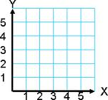  Mark point ( 2, 4 )

 | THURSDAY | Challenge Math
Number and Operations Base Ten:  5.NBT | 409 X 58 | 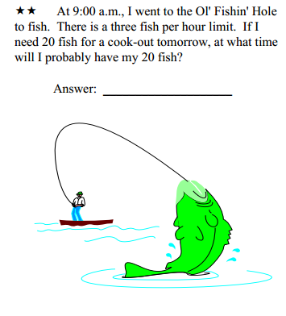  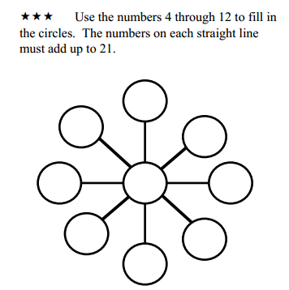  Find combination of 3 numbers that equal 31 and write the equation.  (1 pt. for each correct combination.)
  6 | 1 | 4
  5 | 9 | 8
  2 | 7 | 3
Number and Operations Base Ten:  5.NBT | Mari is making duct tape bracelets to sell. She makes 5 bracelets each hour and sells the bracelets for $2.50 each. If she makes bracelets for 3 hours and sells them all, how much money will she get?
Operations and Algebraic Thinking  5.OA | Write an expression that means 9 less than the quotient of 60 divided by 3.
Number and Operations Fractions:  5.NF | What is 2/8 written in lowest terms?
Number and Operations Base Ten:  5.NBT | 605 ÷ 9
Operations and Algebraic Thinking  5.OA | Evaluate the expression  45 – 7 x 2 + 5 x 4
Geometry:  5.G | Acute, Right, or Obtuse Angle?  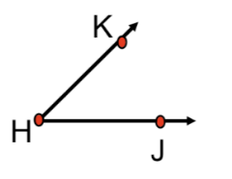
Measurement and Data:  5.MD | 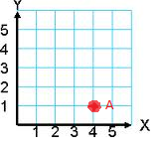  What are the coordinates for point A?  ( ______ , ______ )

