Fifth Grade Weekly Homework Sheet 2
Name_____________________ (Work is done on notebook paper. Answers go here.) Score_________________
CCSS | MONDAY | WEDNESDAY | THURSDAY
Number and Operations Base Ten:  5.NBT |  |  | 268 X 47
  48, 499.11 + 45,347.86
  Round to the nearest HUNDRED then add.
  $282,760.07 - $47,744.85
  Subtract, then round to the TENS place
Number and Operations Base Ten:  5.NBT | Write in standard form:  Two hundred eight thousand, twenty-three  _____________________ | Mrs. Robinson is principal of a school with 465 students. She says that there are 16 times as many books in the media center as there are students in the school. How many books are in the media center?  _______________________ | A rug dealer bought 15 rugs that cost $462 each. How much did the rugs cost in all?  ________________________
Operations and Algebraic Thinking  5.OA | Write an expression that means add 4 and 10, then multiply by 12 | Evaluate:  5 + 2 x 8 ÷ 4 + 11 | Evaluate:  20 – 6 ÷ 3 x 5 - 2
Number and Operations Fractions:  5.NF | Draw a number line that shows 0 to 1, then label the following fractions: 1/3, 2/3 | 3/8 + 5/8 | What is 4/8 written in  lowest terms?
Number and Operations Base Ten:  5.NBT | 1,963 + 64,609 | 801-78 | 905 ÷ 8
Operations and Algebraic Thinking  5.OA | Evaluate:  5 x (2 + 6) ÷ 4 + 10 | 783  9 | 4 ˖ 9  3
Geometry:  5.G | Draw a line of symmetry for the following figure.  | What do you call a figure with  a. 3 sides? _______________  b. 4 sides? _______________  c. 5 sides? _______________ | What is the area of a garden that is 10 feet wide  and 15 feet long?  (Draw and solve.)
Measurement and Data:  5.MD | 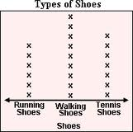  How many students wore  walking shoes?  _________________ | Find the rule and complete the two blank spaces for minutes.  Rule: __________________________ | 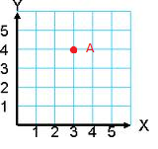  What are the coordinates for point A? ( ____, _____ )
  Hours | Minutes
  1 | 60
  10
  27
All work must be shown on your organized and labeled work page.
The work page gets turned in with this work.

Challenges
You are expected to attempt each Challenge. Points will be awarded for correct answers.
Give it your best shot. You won’t lose points for trying.
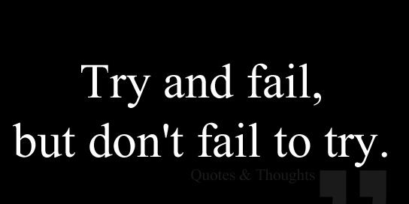
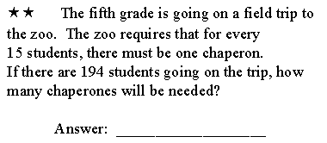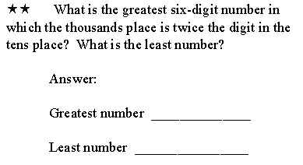
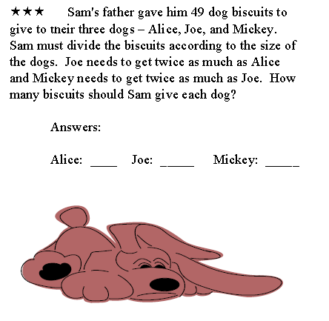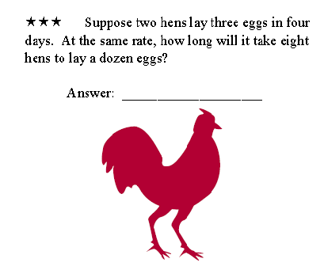

Challenge Bonus Points: _________/ 10

