Fifth Grade Weekly Homework Sheet 12
Name_________________________ Date_______________________ Score: ______________________
 | MONDAY | WEDNESDAY
1. |   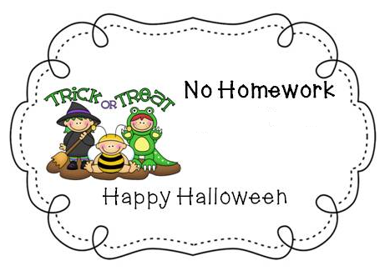 | $ 719,455.78  - $ 52,853.19  Subtract, then round to the nearest tenth of a dollar
2. |  | 1000 x 15.567 =
3. |  | What is the value of the expression below? 4 x (9 – 6)  A. 12 B. 15  C. 30 D. 60
4. |  | List the first 5 multiples of:  8:  6:  Circle the smallest number common to both lists. This is the least common multiple (LCM).
5. |  | I have 9 millions, 3 ten-thousands, 14 hundreds, 11 tens, 7 thousands, 8 tenths, 5 hundredths, and 17 thousandths.  What number am I? __________________
6. |  | What is the Rule?
  Gallons | Cups
  1 | 16
  2
  3
7. |  | Name this figure:    ________________________
8. |  | Angelina wrote the number pattern below.  11 101, 122, 143, 164, 185?  She adds the same number each time to find the next number in the pattern. What is the next number in Angelina’s pattern?  ______________________

THURSDAY | CHALLENGE - BONUS
$836, 925.08  - $74,954.15  Subtract, then round to the nearest  ten thousand dollars. | ★★★ 1. Five flags are evenly placed around a track. It took a runner 30 seconds to get from the first flag to the third flag. If the runner continues at the same speed, how long will it take her to get completely around the track?  Answer: _____________________  (Helpful Strategy: Draw a picture.)
1000 x 5.236 =

Mark wrote an order of operations problem below but forgot to put the parenthesis. If he wants the answer to be 5, where should he put the parenthesis?
30 – 20 ÷ 2
List the first 5 multiples of:  4:  12:  Circle the smallest number common to both lists. This is the least common multiple (LCM). | ★★ 2. What are the next two numbers in  this pattern?  0, 1, 1, 2, 3, 5, 8, _____, _____
Write an expression than means 100 less than the product of 20 times 25.
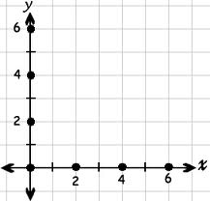
What point is 2 above and 2 right of point (3, 4)?
_____________ Mark it on the grid.
< or >?  - 0.72 ____ 0.7  - 5.871 ____ 5.9  - 0.31____1.3 | ★★ 3. George, Susan, Henry, and Sarah are 7, 8, 9, and 10 years old. Henry is older than Sarah and younger than George. Susan is younger than Henry and older than Sarah. What is each person's age?  George's age ___________  Susan's age ___________  Henry's age ___________  Sarah's age ___________
X | Y
10 | 41
5 | 21
25 | 101
What is the rule?

