Challenge Fifth Grade Weekly Homework Sheet 1
Name_________________________________________ Date______________ Score _________
CCSS | MONDAY | WEDNESDAY
Number and Operations Base Ten:  5.NBT
  72, 439.11 + 25,348.86
  Round to the nearest
  HUNDRED, then add.
  $141,760.37
  - $66,744.85
  Subtract, then round to the TENS place
Number and Operations Base Ten:  5.NBT | Write in standard form:  Ten thousand, twenty seven | Susan and Joe are jumping cracks in the sidewalk.  If there are 8 houses with 14 cracks in the sidewalk in front of each house, how many cracks are  there in all?
Operations and Algebraic Thinking  5.OA | Write an expression that means  3 more than 15 | Solve: 3 + 2 x 10
Number and Operations Fractions:  5.NF | If 4 friends share a pizza, how much  will each person get? | 2/3 + 1/3 =
Number and Operations Base Ten:  5.NBT | I have 3 hundreds, 17 tens,  13 ones, 1 tenths and 2 hundredths. What number am I?  _________________ | Represent the amount, one tenth, in four different ways.
Operations and Algebraic Thinking  5.OA | Solve: 2 x (2 + 6) ÷ 4 | 483  3
Geometry:  5.G | Describe a rectangle in as much detail  as possible. | What kind of units are used when finding area?
Measurement and Data:  5.MD | 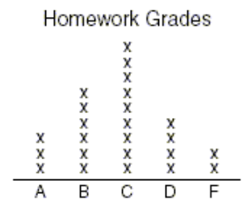  18 students scored C or higher. T or F? | 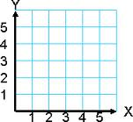  Mark point (2, 4)

CCSS | THURSDAY | CHALLENGE
Number and Operations Base Ten:  5.NBT | 427 X 18 = | **Find a combination of 3 numbers that equal 16 and write the equation.
  6 | 1 | 4
  5 | 9 | 8
  2 | 7 | 3
Number and Operations Base Ten:  5.NBT | Order the decimals from least to greatest.  0.21, 0.2, 0.02, 0.12  _______ _______ _______ _______
Operations and Algebraic Thinking  5.OA | Solve: 20 – 6 ÷ 2 x 5 =
Number and Operations Fractions:  5.NF | 5/6 – 2/6 = | What is the rule?
  X | Y
  1 | 6
  2 | 9
  10 | 33
Number and Operations Base Ten:  5.NBT | Explain in writing what “borrow,” “trade,” or “regroup” means in subtraction.
Operations and Algebraic Thinking  5.OA | 5 ˖ 8  4 | 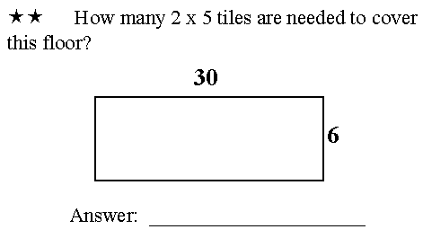
Geometry:  5.G | Draw line ST parallel to line MN | 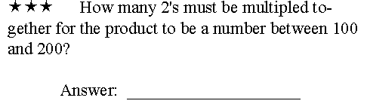
Measurement and Data:  5.MD | What are the coordinates for point A?  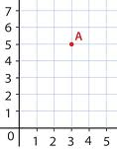  What are the coordinates for point A? | 

