How to Prepare for Tulip Planting

Students will be doing most of the planting with the help of Miss Carmen and me. Since we will be digging in the soil, I ask that you help your child be prepared in case they get a little dirty. Here are some suggestions.  
 Clothing:   
 *Old clothes or work clothes (jeans, long sleeve  
 shirts, etc.)   
 *Rain/ work boots or old tennis shoes  
 *A hat or sunglasses if it is sunny  
 Tools: (Optional)  
 *Garden gloves  
 *Small trowels

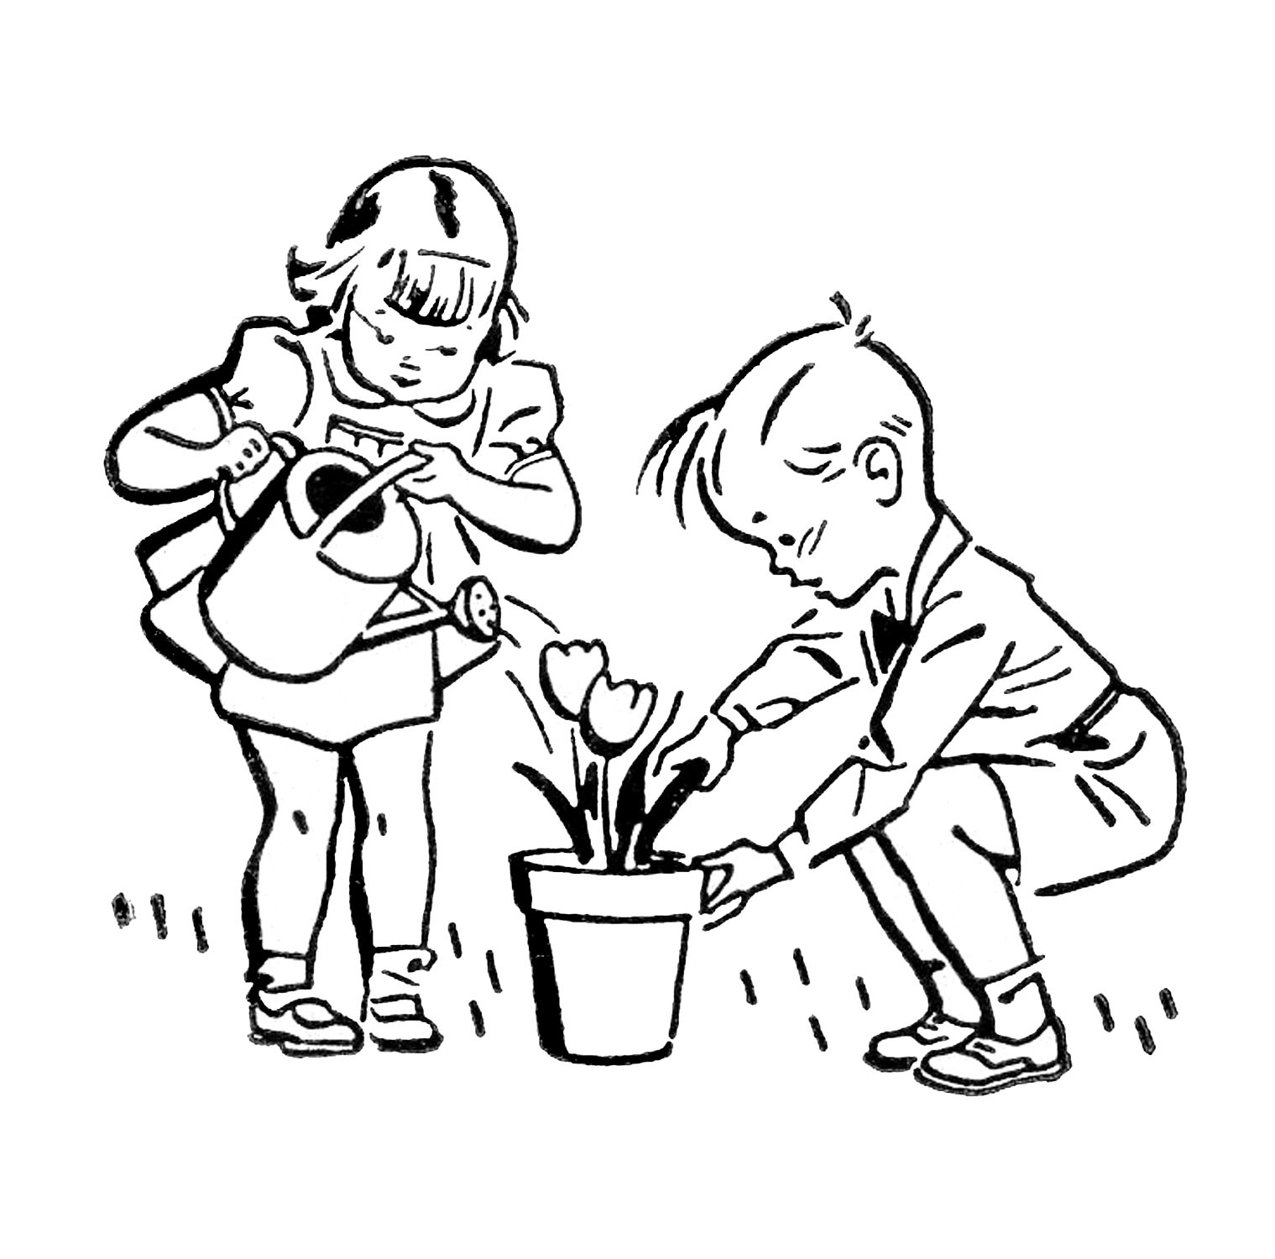

Challenge Schedule

Monday & Thursday 10:25 – 12:05  
Wednesday & Friday 2:05 – 3:25*  
No Class on Tuesday   
*German with Herr Holmes at 3:00

Check out my new website:

<http://mrsrinkel.weebly.com/>



Here you will find information and photos for our Challenge class. There are even a few German resources for you, too.

Brookwood Challenge   
1st Grade

Mrs. Vanessa Rinkel   
Email: [vanessa.rinkel@dalton.k12.ga.us](mailto:vanessa.rinkel@dalton.k12.ga.us)

School Phone: (706) 278-9202



Join my Remind page to keep up to date and stay informed. Instructions to sign up for Remind are on the back of this sheet.







First Grade Challenge  
December News



**It’s tulip planting time!   
Please join us if you can.**

**When:** December 10, 2015  
 at 10:45 a.m.  
Where: Brookwood School  
 Front Butterfly Garden

Students will be planting the tulips we received in November as part of our Journey North Tulip Garden. This global climate study will have citizen scientists track changes in seasons and climate by using tulips to determine the onset of spring. Visit the Journey North   
website here: https://www.learner.org/jnorth/tulip/